Canada needs a Revolution in Math Education

John Mighton

Our declining math scores are a reflection of a system that expects only a few students to succeed.

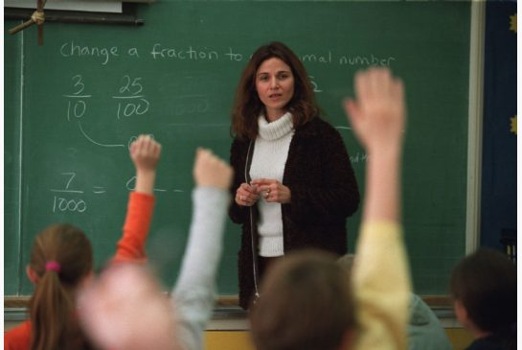
Tony Bock / TORONTO STAR Order this photo. Bessie Anastopoulos teaches a grade 6 class at Rosedale Public School in Toronto.
Many people have asked lately why Canadian students don’t do as well on international math tests as those in countries like Finland and Singapore. But the data suggest that we should also ask how countries that rank higher than Canada still manage to teach so little to almost half their populations. On the recent OECD-run math exam, about 40 per cent of students in top ranked countries demonstrated a level of competence that would exclude them from jobs that require a good understanding of math.
Wide differences in mathematical achievement among students appear to be natural: in every school, in every country, only a few students are ever expected to excel at or love learning mathematics.
In 2007, Toronto teacher Mary Jane Moreau gave her fifth grade students a standardized math assessment called the TOMA. The class average was in the 54th percentile, with marks ranging from the 9th to the 75th percentile. But then Mary Jane adopted a new curriculum. Designed by the educational charity JUMP Math, the methods were based on the assumption that all children can be led to think mathematically. After a year of the new techniques, the average rose to the 98th percentile, with the lowest mark in the 95th percentile. At the end of grade six, the class wrote the Pythagoras Math competition: 14 of the 17 students received awards of distinction, with the other three close behind.
When children decide they aren’t talented in math, their brains work less efficiently: they stop paying attention, taking risks and persevering in the face of difficulty, and they often develop anxieties or behavioural problems. By making everyone feel capable, Mary Jane was able to produce a class of students who were, to a surprising degree, equally capable.
These results are not isolated: researchers from the Hospital for Sick Children found that students in regular classrooms using JUMP showed twice the rate of progress on tests of math ability as students receiving standard instruction. As controlled studies rarely show such striking differences between math programs, the U.S. Department of Education has funded a larger study by the same team.
In the past 15 years most schools in North America have adopted some kind of “discovery” based program in which students are expected to figure things out for themselves rather than being taught them explicitly. While I have great respect for the aims and methods of discovery, a growing body of research in cognitive science suggests that discovery only works if it is combined with the teaching of basic facts (like times tables), continuous assessment, practice and a good deal of guidance from the teacher.
Teachers are sometimes criticized for low test scores, but they are not to blame. Teachers must be allowed to innovate and test new methods and they shouldn’t be required to use programs that aren’t based on rigorous research. I have seen again and again that teachers are eager to try new methods if given the chance, and that this can improve their own knowledge of math without costly and time-consuming retraining (not that that shouldn’t be part of the solution, too.)
Low levels of achievement in math impose huge losses on the economy. But there are other losses that are harder to put a price on.
To progress as a society, we must recognize that there is such a thing as intellectual poverty. Children can enjoy doing math as much as they enjoy making art or playing sports. It’s fun to overcome challenges and thrilling to discover or understand something that is beautiful, useful or new. Children love solving puzzles, seeing patterns and making connections. They have a sense of wonder that is only diminished by failure. If we could keep a record, even for a day, of all of the opportunities for emotional and intellectual engagement with the world that are lost when a child decides he is not smart enough to keep up with his peers, we would finally understand the staggering impact of intellectual poverty.
To bring about a revolution in education, we must insist that every child has a right to fulfil their intellectual potential, just as they have a right to develop healthy bodies. We don’t have to wait until we have recruited an army of super human teachers to transform our schools and our society. We simply need to give the teachers we have now the means to teach children using effective methods that are backed by scientific evidence.
John Mighton, O.C., is founder of the charity JUMP Math and a fellow of the Fields Institute for Research in the Mathematical Sciences.

